IMPORTANT ANNOUNCEMENT

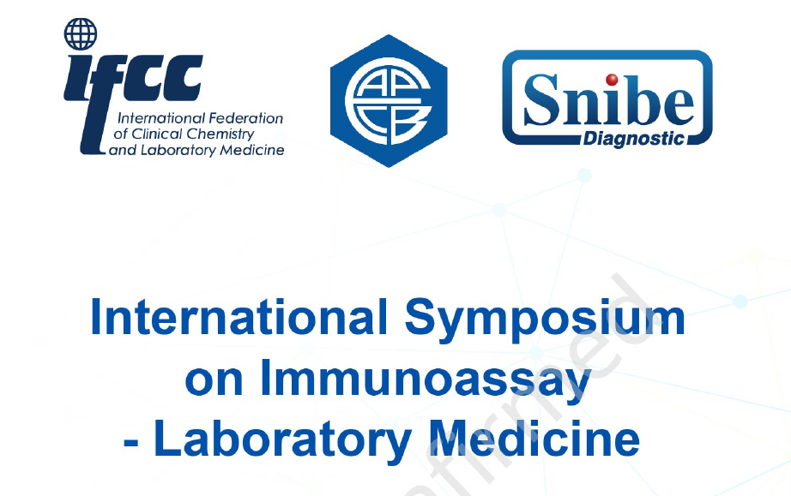
To all MACB members,
You are invited to apply for the MACB- SNIBE Travel Grant to attend the International Symposium on Immunoassay-Laboratory Medicine which will be held in Shenzen, China on 26th August, 2023. Please refer to symposium programme for details on the lecture topics.
This grant covers symposium registration, flight, accommodation and meals. Inland travel is not included. Accommodation will be for a 3-night stay (Check-in date is 25th and check-out date is 28th August 2023).
Interested members may apply using the attached form. Please attach a brief CV together with the application form. Closing date is 9th July, 2023.

APPLICATION FORM
MACB-SNIBE TRAVEL GRANT
To Attend the the International Symposium on Immunoassay-Laboratory Medicine which will be held in Shenzen, China on 26th August, 2023
- Personal details
Name
Place of work
Office Address
Current job position
Contact number
Email address

- MACB membership
MACB member
Year of joining
Membership status
Current position in MACB council / committees

Contribution to MACB activities

- Previous MACB support received in the last 6 years - (MACB travel grants / financial support to attend conferences and scientific meetings etc.)
Name of event (1)

Country |  | Year
Role | Presenter / Participant / Others (please specify)

Name of event (2)

Country |  |  | Year
Role | Presenter / Participant / Others (please specify)
Name of event (3)

Country |  |  | Year
Role |  | Presenter / Participant / Others (please specify)

- Reason for application.

- Expected benefits

……………………………………………………………………
Signature
Name:
Date:

Note:
- This support covers symposium registration, flight, accommodation (3-nights) and meals. Inland travel is NOT included.
- Please attach a brief CV (Max 300 words).
- Closing date is 9th July, 2023.

