IMPORTANT ANNOUNCEMENT
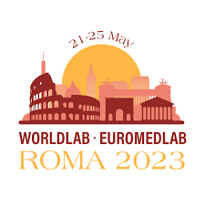
To all MACB members,
You are invited to apply for the MACB- SNIBE Travel Grant to attend the WorldLab EuroMedLab 2023 which will be held in Rome from 21-25 May, 2023.
The XXV IFCC-EFLM EuroMedLab Congress, will be jointly hosted by IFCC, EFLM, and the Italian Society in partnership with MZ Events. The 2023 EuroMedLab Congress will feature innovative and diverse education opportunities, including lectures, symposia, recent advancements in clinical practice and science, poster presentations, and industry exhibits, as well as an excellent social program. Attendees will thereby have the chance to interact with distinguished experts from around the world.
This grant covers conference registration, flight and accommodation. Meals and inland travel are not included.
Interested members may apply using the attached form. Please attach a brief CV together with the application form. Closing date is 17 Mac, 2023.

APPLICATION FORM
MACB-SNIBE TRAVEL GRANT
To Attend the Worldlab Euromedlab In Rome Italy, 21-25 May, 2023
- Personal details
Name
Place of work
Office Address
Current job position
Contact number
Email address

- MACB membership
MACB member | Yes |  | No
Year of joining
Membership status | Active |  | Not active
Current position in MACB council / committees

Contribution to MACB activities

- Previous MACB awards / grants / sponsorships received
Name of event

Country
Year

Name of event

Country
Year
- Reasons for application.

……………………………………………………………………
Signature

Name: …………………………………………………………
Date: ………………………………………………………….

Note:
- This support covers conference registration, flight and accommodation. Meals and inland travel are not included
- Please attach a brief CV
- Closing date is 17 Mac, 2023

